1. Search in http://scholar.google.co.uk | 2. Find an interesting title.
3. Open the research paper. | 4. In the conclusion find an interesting sentence.
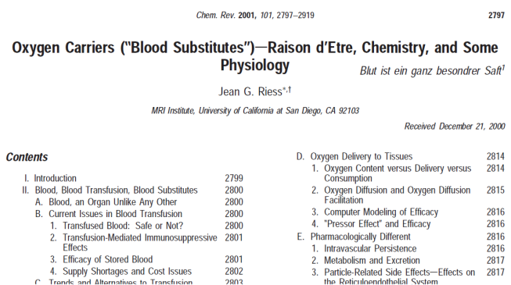
5. Cite the reference in your essay. | 6. Format the reference in the APA format.
Riess (2001) states that over time, the definition of blood substitutes “has evolved”. Reiss goes on to explain that “the initial intent of developing an all purpose “artificial blood” to be used instead of, and in the same circumstances as, blood has progressed into the more realistic goal of providing the physician with a novel means of temporarily alleviating tissue hypoxia and its consequences. This could be especially important for avoiding or reducing the surgical and critical care patient exposure to allogeneic blood and could be used in conjunction with, including global strategies for better using a patient’s own fresh blood.” (2001, p.2894) | References  Riess, Jean G. (2001). Oxygen Carriers (“Blood Substitutes”) sRaison d’Etre, Chemistry, and Some. Chemical Reviews, 101(9). San Diego: MRI Institute
If you can only see the Abstract…. | ...the 1st sentence & last sentences often give good quotes.
Many experts suggests that perfluorocarbons have shown promise as clinical blood substitutes (Vercellotti, 1982). Vercellotti is hopeful in that while problems can occur, the “adverse reactions to Fluosol are probably mediated by C activation and that steroid premedication may prevent them in susceptible patients.” (1982, 1304)

References
Vercellotti, GM., Hammerschmidt, DE., Craddock, PR & Jacob, HS. (1982). Activation of plasma complement by perfluorocarbon artificial blood. American Society of Hematology. 59 (6), pp.1299-1304.

