Secondary Research
Details at: http://pittayakom.weebly.com/assignment-2.html Email for help and revision: ajarntim2555@gmail.com
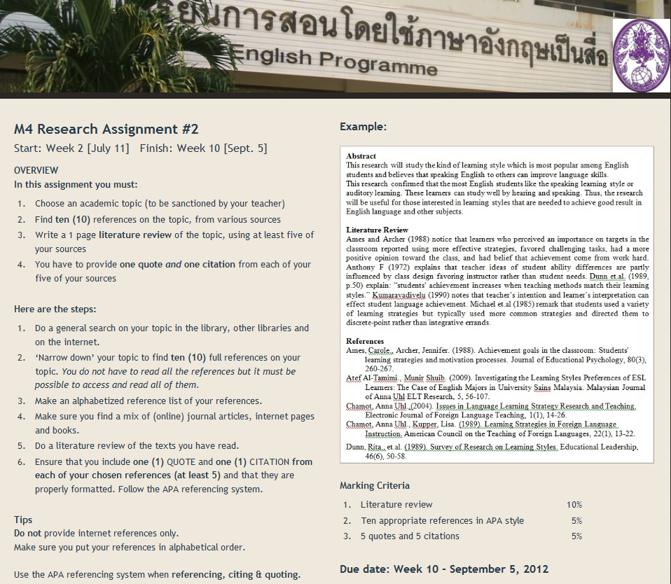

Finished!
You have 5 already!
Almost finished!
To be completed

