All_Vocab_v1_0.xlsm Instructions

Opening the File
This is a Macro Excel file. When you open this file, you will receive a message similar to warning on the right.  Click Enable Content.  This will allow the macros to function.  If you do not enable the macros, but click the buttons on the sheets, you will get a  message similar to the following: | 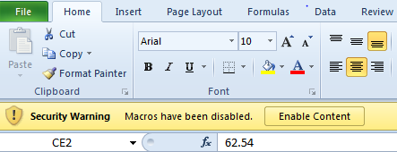
M_Order Tab
Provides Vocabulary Overview and List of English/Thai words for Matthayom Level and Semester (can be copied).
Choose the M level (M1-M3 at J1 / M4-M6… at J64 )  Choose the Semester (M1-M3 at H2 / M4-M6… at H65 )  The list in C:C and D:D will change accordingly.  Copy these columns if required.  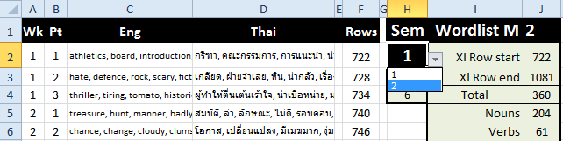 | 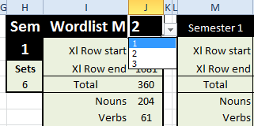

Important Notice
Tab | Exercises | Level
L_Vocab | Word Scrabble and Cloze Sentences (18 each) | M1, M2, M3
U_Vocab | Word Scrabble and Cloze Sentences (20 each) | M1, M2, M3, M4, M5, M6, SAT, TOEFL, AWL
Sent. Wksheet | Sentence Completion (20 + Easy / Hard words) | M1, M2, M3, M4, M5, M6, SAT, TOEFL, AWL
Syn. Wksheet | Synonyms (30 groups of 3 synonyms + 1 antonym ) | M1, M2, M3, M4, M5, M6, SAT, TOEFL, AWL
Adj. Wksheet | Noun-Adjective-Adverb (30 Sentences to complete) | M1, M2, M3, M4, M5, M6, SAT, TOEFL, AWL
Mix_Wksheet | Sentence Creation (30 scrambled sentences with clues) | M1, M2, M3, M4, M5, M6, SAT, TOEFL, AWL
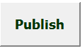
Main adjustments are first made on the design pages. Every design page has a Publish button.
Choose the Matthayom Level, Week, Semester from any Worksheet that shows the Publish button.
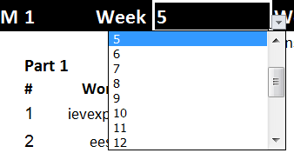
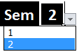

Choose Level
Choose Week
Choose Semester

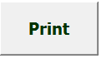

If you are on a page with a button, click buttons above to return to a design page.

L_Vocab tab
Word Scramble for students to match to definitions.  18 Exercises  Level: M1, M2, M3 | 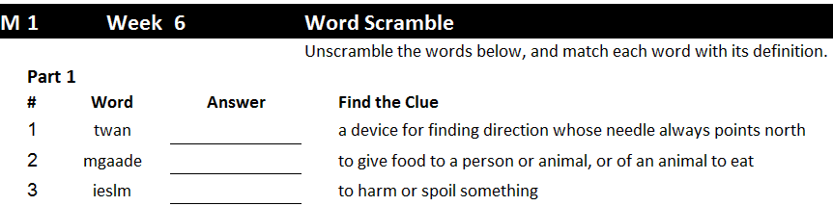
Cloze Sentences for students to choose the word for each sentence.  18 Exercises  Level: M1, M2, M3 | 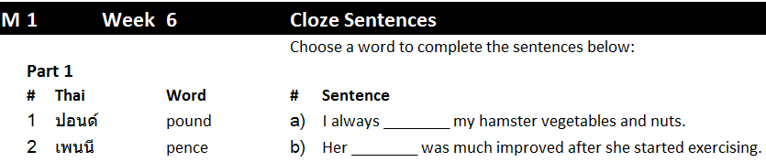
U_Vocab tab
Word Scramble for students to match to definitions.  20 Exercises  Levels: M4, M5, M6 TOEFL, SAT, AWL | 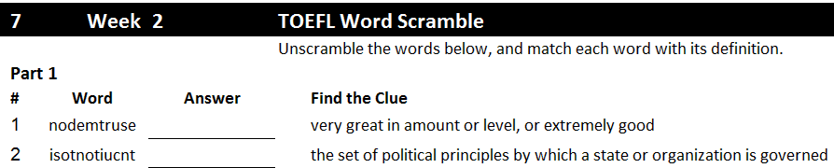
Cloze Sentences for students to choose the word for each sentence.  20 Exercises  Levels: M4, M5, M6, TOEFL, SAT, AWL | 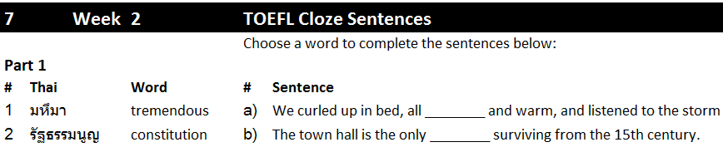

On Design Page On Print Page
Press F9 to re-scramble letters in each word
To scramble the definition for each word | 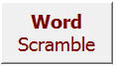 | Shows solutions for | 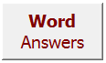
To match the definition with each word | 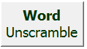 | To remove answers for students | 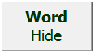
Press Publish to publish the current options for the Print page | 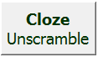 | To return to design page | 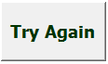
 | 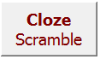 | To publish the current options for the Print page | 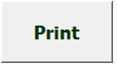
To transfer current options to Print page | 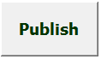

Sent. Wksheet  Sentence Completion for students to choose a target language word to complete sentences.  20 Exercises  Levels: M1, M2, M3 M4, M5, M6, TOEFL, SAT, AWL | 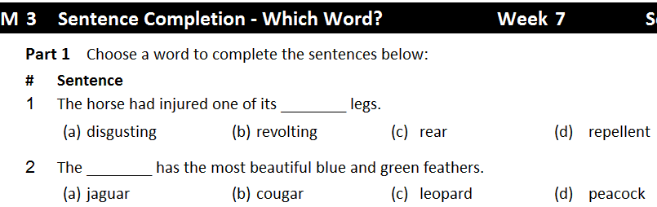

On Design Page On Print Page
Press F9 to re-scramble letters in each word Shuffle, Simple, Hard buttons return to design page.
To scramble the definition for each word  On Print page, returns to design | 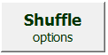 | To remove answers for students | 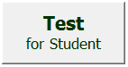
To match the definition with each word  On Print page, returns to design. | 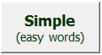 | To match the definition with each word | 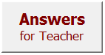
To publish the current options for the Print page  On Print page, returns to design | 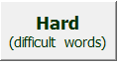 | To publish the current options for the Print page | 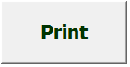
To transfer current options to Print page | 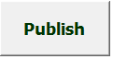

Syn. Wksheet  Sentence Completion for students to choose a target language word to complete sentences.  20 Exercises | 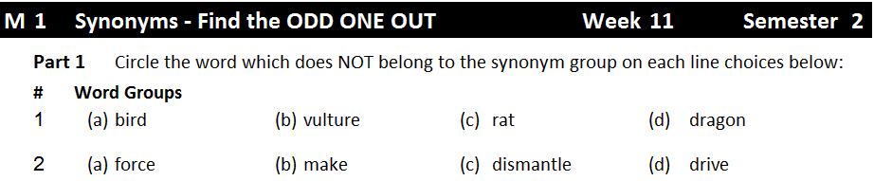
Levels: M1, M2, M3 M4, M5, M6, TOEFL, SAT, AWL

On Design Page On Print Page
Press F9 to re-scramble letters in each word Shuffle, Simple, Hard buttons return to design page.
To scramble the definition for each word  On Print page, returns to design |  |  | To remove answers for students
To match the definition with each word  On Print page, returns to design |  |  | Press Word Unscramble to match the definition with each word
To publish the current options for the Print page  On Print page, returns to design |  |  | To publish the current options on the Print page
To transfer current options to Print page
Adj. Wksheet  Choose the noun, adjective, or adverb missing from each sentence.  20 Exercises  Levels: M1, M2, M3, M4, M5, M6, TOEFL, SAT, AWL | 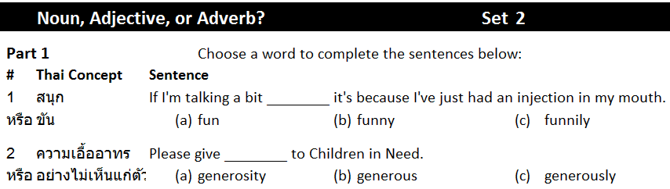

On Design Page On Print Page
Press F9 to re-scramble letters in each word Shuffle, Simple, Hard buttons return to design page.
Noun-Adj-Adverb placed in order |  | 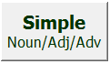 |  | Test removes answers for students
Scrambles Noun-Adj-Adverb order |  | 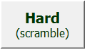 |  | Answers shows completed sentences |  |  | 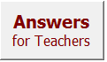
To transfer current options to Print page | 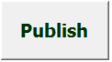 |  | To return to design page |  | 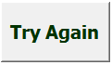 | To print current Worksheet page | 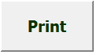

Mix_Wksheet  Sentence Completion for students to choose a target language word to complete sentences.  20 Exercises  Levels: M1, M2, M3 M4, M5, M6, TOEFL, SAT, AWL | 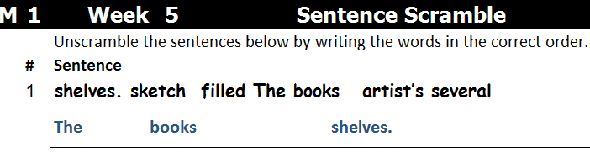

On both design and print pages
Press F9 to re-scramble letters in each word Shuffle, Simple, Hard buttons return to design page.
Press Word Scramble to scramble the definition for each word | 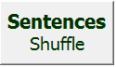 | Press Word Scramble to scramble the definition for each word |  | 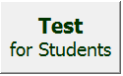
Press Word Scramble to scramble the definition for each word | 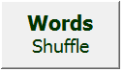
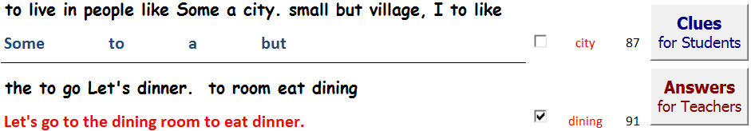 |  |  |  |  | Clues for words in order.  Answers for sentences.  On Print page, option to vary
To transfer current options to Print page |  | To publish the current options on the Print page

